Erasmus + UK Timetable 3rd to 7th October 2016

Students spend 3 nights with host families and 3 nights at Holt Hall.
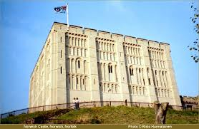
Monday 3rd October - Welcome to our school!
8.45 am: Arrive at school
9.30 am: Welcome Ceremony
10.30: Break time
11 am: Lesson 1 - History
12.30: Lunch at school
1.15 pm: Leave school for city centre - Castle, cathedral and city tour
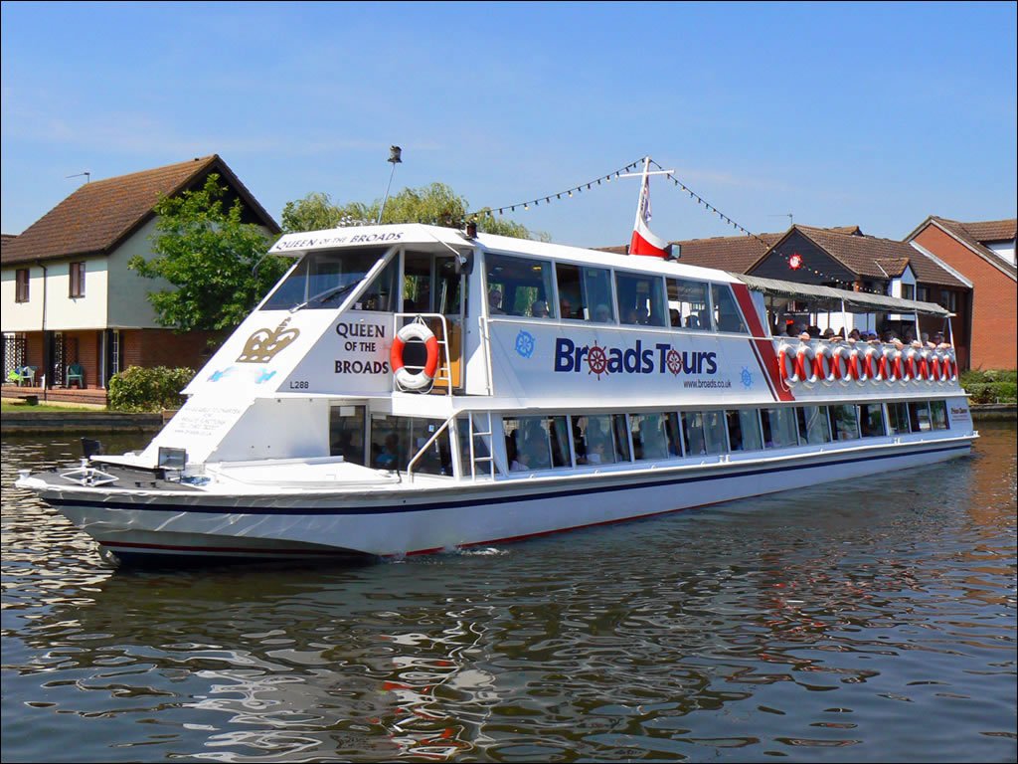
5.30 pm: Meet families at school

Tuesday - Visitor Lessons
​8.45 am: Arrive at school
9 am: Visitor Lesson session 1
9.45 am: Visitor Lesson session 2
10.30 am: Break time
11 am: Visitor Lesson session 3
12 pm: Lunch at school
12.50​ pm: Leave school to go to Wroxham - tour of the Broads
​5.30 pm: Meet families at school
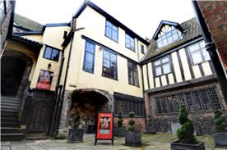
Wednesday - Lessons and Tudor workshop
8.45 am: Arrive at school
9 am: Lesson 2 + 3 - Music and Geography
9.45 am: Lesson 2 + 3 - Music and Geography
10.30 am: Break time
11 am: Lesson 4 - Art and Natural history
12 pm: Lunch at Cafe Britannia
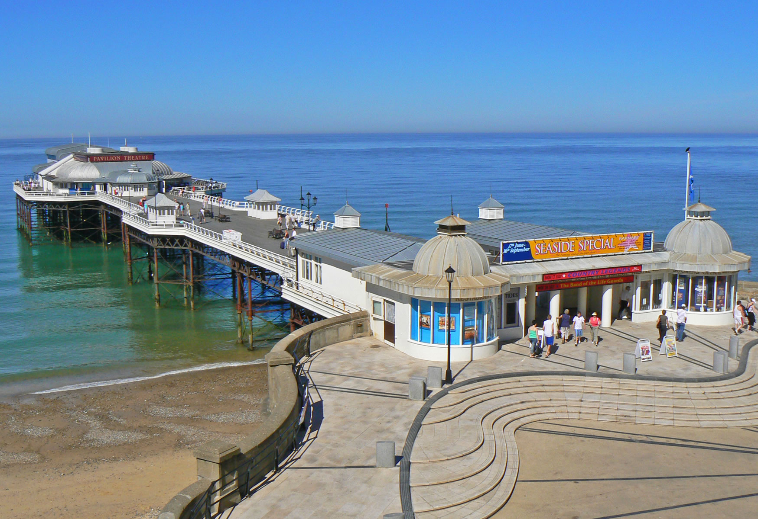
1.15 pm: Leave for Strangers' Hall - Tudor workshop
4 pm: Leave for Holt Hall

Thursday - Exploring North Norfolk
10 am: Steam train from Holt To Sherringham
12 pm: Visit Cromer Pier
1.30 pm: Fish and Chips lunch
2.30 pm: Walk to East Runton along coast
3 pm: Rock pooling at east Runton Beach
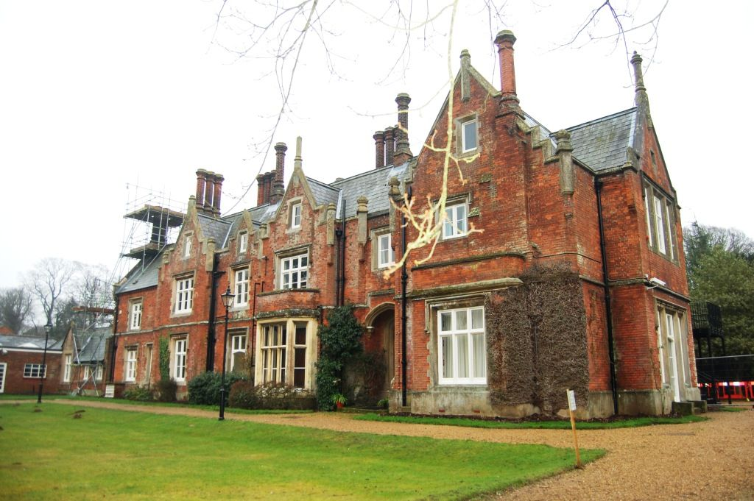
Evening: Dinner and disco!
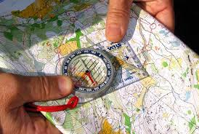
Friday - Day at Holt Hall
​Morning: Orienteering
Afternoon: Team building games
Evening: Popcorn and Film evening

